
Arab Academy of Science and Technology and Maritime Transport COLLEGE OF ENGINEERING & TECHNOLOGY

- Find the address range of the following memory design.
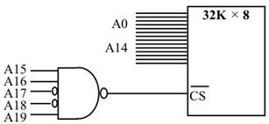
- ​
Using NAND gates and inverters, design decoding circuitry for the address range
0C0000H–0C0FFFH.
- Find the address range for Y0, Y3, and Y6 of the 74LS138 for the following design. This is the ROM interfacing with the 8088 CPU in the original PC.
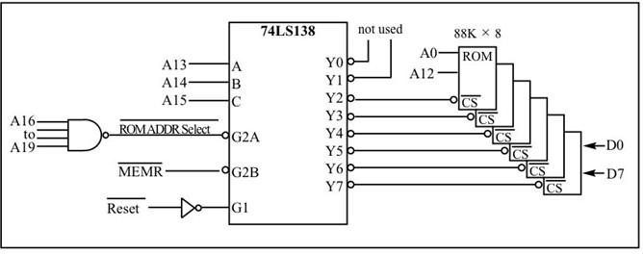
- Using the 74138, design the memory decoding circuitry in which the memory block controlled by Y0 is in the range 00000H to 03FFFH. Indicate the size of the memory block controlled by each Y.
- Find the address range for Y3, Y6, and Y7 in Problem 4.

- Using the 74138 and OR gates, design memory decoding circuitry in which the memory block controlled by Y0 is in the 80000H to 807FFH space. Indicate the size of the memory block controlled by each Y.
- Find the address range for Y1, Y4, and Y5 in Problem 6.
- The CS pin of the memory chip is active (low, high). What about the RD pin?
- Which one can accommodate more inputs, the 74138 or CPLD?

